**Understanding Concrete Damages: Causes, Contributing Factors, and Integrity Assessment**

Suparjo1*, Yuli Panca Asmara2, Firda Herlina3, Jainal arifin3, Robiatul Adawiyah3.

1Mataram University, Civil Engineering, NTB, Indonesia

2INTI International University, Faculty of Engineering and Quantity Surveying,

71800, Negeri Sembilan, Malaysia

3Universitas Islam Kalimantan Muhammad Arsyad Al Banjari Banjarmasin.

**\*Email:** suparjo14867@yahoo.com

**Abstract**

Concrete, one of the most widely used construction materials, is susceptible to various defects that compromise its durability and structural integrity. Deterioration results from a combination of chemical, physical, and environmental factors, including acid attack, chloride penetration, sulfate reactions, abrasion, erosion, fire exposure, and shrinkage cracks. Corrosive agents such as CO₂-rich water, salts, and alkalis accelerate degradation, while physical damage further exacerbates structural deterioration. Additionally, chloride ions reduce the pitting potential, making reinforcement more vulnerable to corrosion. External conditions, such as temperature fluctuations, moisture variations, and pollution, can further contribute to material degradation. This study examines the root causes of concrete defects, emphasizing the influence of material composition, environmental exposure, and construction practices. A deeper understanding of these factors is essential for developing effective mitigation strategies, enhancing quality control measures, and ensuring long-term structural reliability through routine inspections, maintenance, and preventive techniques.

**Keywords**

Concrete damages, concrete integrity structures, concrete rehabilitation

**Introduction**

Reinforced concrete combines concrete’s compressive strength with steel’s tensile strength, creating a durable construction material. Concrete, made from gravel, sand, cement, and water, binds through cement’s calcium, silica, and aluminum oxide. Steel reinforcement remains passive due to concrete’s high pH, protecting it from corrosion (Asmara, 2018, 2022). However, impurities like chlorine ions, sulfates, CO₂, and water can degrade concrete, leading to corrosion and weakening (Bentur, 2011; Kefiyalew, 2016; Zou, 2022). Alkali-silica reactions form hygroscopic gels that expand, causing internal stress and cracking. Concrete deterioration also results from excessive loads, poor mixing, and chemical attacks (Portland Cement Association, 2022). To enhance durability, modifications include adding fine particles (e.g., silica fume, fly ash) to reduce porosity and increase strength. Plasticizers improve ductility, while resin-based alternatives replace cement for improved performance (Burhodos, 2018; Phoo, 2015).

Concrete is a widely used structural material known for its availability, adaptability, and durability. It has high compressive strength comparable to natural stone, composed of sand, gravel, and cement, which hardens through an exothermic hydration process, reaching maximum strength in 28 days (Edward G., 2023). However, concrete has weaknesses such as high density, low tensile strength, susceptibility to cracking, and difficulty in recycling.

To improve its properties, additives like pozzolans and superplasticizers enhance strength, durability, and drying speed. Superplasticizers reduce water content, preventing excessive hydration, while silica fume and fly ash minimize porosity. The choice of aggregates, such as sand, crushed stone, or iron furnace slag, influences concrete's workability and lifespan. Lightweight aggregates like pumice improve water absorption, making them ideal for partition walls.

*Concere damages*

Concrete is highly resistant to water, air, and chemicals, with a lifespan of hundreds of years if undamaged. This makes it ideal for structures in seawater, acidic soils, and industrial environments. However, poor-quality concrete is prone to deterioration, often starting with surface defects. Chemical damage occurs when external elements penetrate through cracks and porosity. To prevent this, concrete must remain solid, crack-free, and low in porosity. If chemical impurities reach the concrete, their concentration must be minimized to prevent corrosion of the steel reinforcement. Low-quality concrete can compromise steel reinforcement by damaging its passive protective film, exposing it to corrosion. External chemicals like water, salt, CO₂, and industrial pollutants accelerate corrosion, reducing concrete strength and durability (Portland Cement Association, 2002). Common corrosion types include uniform, galvanic, and pitting corrosion. Concrete structures deteriorate over time due to mechanical loads and environmental exposure. Preventive measures and repairs are essential to prolong service life, with methods applied either before casting or during use (Bennett, 1993; Matsumoto, 2003; Bastidas, 2008). Selection of curing techniques must consider cost, complexity, and efficiency (Baxi, 2020).

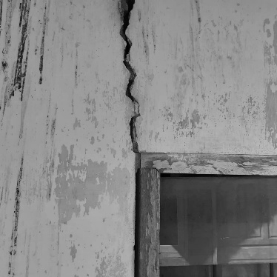 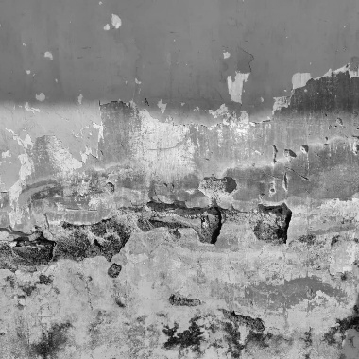 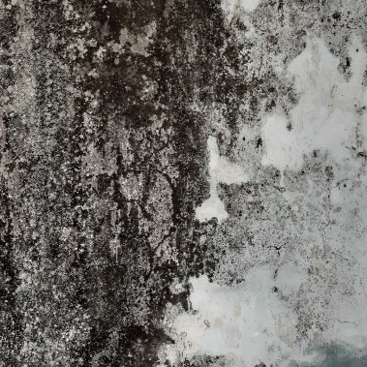

Figure 1. Various surface damages of concretes as a result of its exposure to atmospheric conditions.

*Factors affecting concrete damages*

*Acid*

Portland cement concrete has poor resistance to acids, especially at pH 3 or lower. Acids react with calcium hydroxide in hydrated cement, forming water-soluble compounds that weaken concrete. Sulfuric acid, from fuel combustion or bacteria in sewage, is highly aggressive, causing sulfate attack. Organic and mineral acids from industrial waste, animal manure, fruit juices, and acid rain can also deteriorate concrete. Acidic soils and CO2-rich water corrode concrete by dissolving calcium. To prevent acid damage, concrete surfaces must be protected with a protective layer.

*Chloride*

Reinforced concrete exposed to chloride ions, especially from seawater, can corrode if oxygen and water vapor are present. Chloride penetrates through cracks, breaking the steel's protective oxide film and increasing corrosion risk. Corrosion starts when chloride levels exceed a threshold, but only water-soluble chlorides contribute to damage. Chloride ions accelerate steel reinforcement corrosion by disrupting concrete's protective alkaline layer. They penetrate through de-icing salts, seawater, and contaminated materials, leading to rapid deterioration. The role of chloride in accelerating the corrosion rate is formulated in Equations 1 - 3.

*Fe2+ ​​+ Cl- → FeCl2*(1)

*FeCl2 + 2H2O → Fe(OH)2 + 2Cl-*(2)

*6FeCl2 + O2 + 6H2O → 2Fe3O4 + 12H+ + 12Cl-* (3)

Fugue 2 demonstrates the effects of chloride on the corrosion rate by reducing the pitting potential and increasing the corrosion current density. The presence of chloride ions accelerates localized corrosion by breaking down the protective passive film on metal surfaces, making the material more susceptible to pitting.

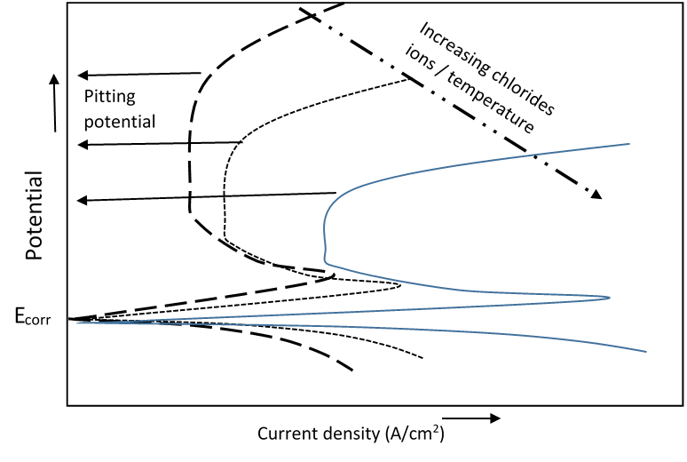

Figure 2. Effects of chloride on the corrosion rate and pitting potential. (Asmara, Y. P., 2024).

*Salt and Alkali*

Ammonium, chlorides, nitrates, and metal ions can damage concrete, with ammonium being the most destructive. In an alkaline environment, ammonium salts release hydrogen ions, dissolving calcium hydroxide. Strong alkalis (>20%) also cause concrete disintegration.

*Sulfate Attack*

Sulfates from soil and groundwater react with hydrated cement, forming ettringite and gypsum, which weaken concrete. Magnesium sulfate further degrades concrete by lowering pH and decomposing calcium silicates. Wet/dry cycles accelerate deterioration as sulfate salts accumulate and crystallize, causing cracks. Seawater contains sulfates, but its effects are less severe. Sulfate resistance improves with a low water-cement ratio and sulfate-resistant cement (ASTM C 1157 types MS & HS). Certain pozzolans and blast-furnace slag enhance resistance, while calcium chloride reduces it and should be avoided.

*Carbonation*

Carbonation occurs when CO₂ penetrates concrete and reacts with calcium hydroxide, forming calcium carbonate (Equation 4):

Ca(OH)₂ + CO₂ → CaCO₃ + H₂O (4)

This reaction lowers the pH to 8.5, destabilizing the passive film on steel. Carbonation progresses slowly, around 1.0 mm per year in high-strength concrete, and accelerates in high water-cement ratio (w/c) concrete. The process is most active at 50%-75% relative humidity but slows at <25% or >75% due to moisture resistance to CO₂ penetration. Carbonation also reduces the chloride threshold for steel corrosion. In fresh concrete (pH 12-13), 7,000-8,000 ppm of chloride is needed to initiate corrosion, but at pH 10-11, corrosion can start at <100 ppm. Corrosion risk depends on carbonation depth relative to concrete cover thickness (see Table 1).

Table 1. Criteria for damage to concrete based on the carbonation reaction. *dcar/dcoat is depthcarbonation and concrete cover thickness ([Rita B. Figueira](https://sciprofiles.com/profile/108051), 2017).

|  |  |  |  |
| --- | --- | --- | --- |
| *dcarb*/d*coat | ConcreteCondition | Rebar Condition | Risk of Corrosion |
| <0.5 | No cracking | Passive | Negligible |
| >0.5 | No cracking | Passive | Low |
| ≈1.0 | Small cracking | Low to moderate corrosion | High |
| >1.0 | Cracks, minor detachment/spalling | Moderate to high corrosion | Very High |
| >>1.0 | Cracks, high detachment/spalling | High corrosion with substantial loss of section | Very High/Severe |

*Alkali Aggregate Reaction*

While most aggregates are inert, some react with concrete’s alkali hydroxides, causing expansion and cracking. This reaction occurs in two forms:

* Alkali-Silica Reaction (ASR)
* Alkali-Carbonate Reaction (ACR)

ASR forms a soluble, hygroscopic sodium silicate gel (NSH), which swells upon absorbing water, creating internal stresses. This leads to aggregate expansion, surface peeling, and concrete strength loss, eventually causing structural failure.

ASR causes deep, random cracks and surface peeling, especially in moisture-exposed areas like waterlines, retaining walls, joints, and columns under axial loads. Expansion occurs when moisture concentration exceeds a critical level, but ASR can be minimized by keeping concrete dry, ideally below 80% internal humidity (Asmara, 2024).

*ASR Mechanism:*

1. Alkalies (NaOH/KOH) react with silica aggregates, forming a soluble, viscous sodium silicate gel (NSH, KSH).
2. The reaction lowers cement pore pH, dissolving calcium hydroxide (Ca(OH)₂).
3. Calcium ions (Ca²⁺) react with the silicate gel, forming solid calcium silicate hydrate (CSH).
4. CSH forms a low-permeability layer, reducing further expansion.

*External Factors Causing Concrete Damage*

*Abrasion/Erosion*

Abrasion occurs when friction, impact, or wind exposes fine and coarse aggregates, commonly affecting highways, dams, waterways, offshore structures, and tunnels. In industrial areas, heavy vehicles contribute to abrasion. In hydraulic structures, abrasion is caused by debris like mud, sand, and gravel. High-strength concrete with hard aggregates improves resistance. Abrasion erosion is identified by wear patterns and cavitation holes.

*Cavitation Erosion*

Cavitation erosion results from gas or vapor bubbles collapsing, creating microjet forces that deform the surface, causing pitting, noise, and vibration. When combined with erosion, damage intensifies, altering flow patterns. Cavitation leaves irregular, rough-edged wear and, in severe cases, forms a “Christmas tree” pattern on waterways. Using high-strength concrete is the most effective prevention.

*Fire/Heat*

Concrete weakens at high temperatures, with elastic modulus being the most sensitive, followed by flexural and compressive strength. Key observations:

* Thermal cycling causes more strength loss than constant high temperature due to uneven expansion between cement paste, steel, and aggregate.
* Limestone/calcium aggregates offer better thermal resistance than silica-based aggregates.
* Strength loss is independent of concrete’s compressive strength.
* Lower W/C ratio reduces elastic modulus loss.
* Trapped moisture can cause flaking if heated too quickly.

*Volume Change*

Concrete undergoes volume changes due to moisture fluctuations and temperature variations. If restrained, contraction can cause tensile stress, leading to cracking.

* Shrinkage Cracks: Occur when water evaporates too quickly from fresh concrete, causing surface cracks. Preventative measures include mist spraying, plastic sheeting, and windbreaks to reduce evaporation.
* Thermal Cracking: Results from expansion due to heat and contraction when cooled. Aggregates significantly influence thermal response. Proper design should allow for expansion/shrinkage, especially before the concrete reaches full strength. Overloading can also cause thermal cracking.

*Surface Defects in Concrete*

Concrete surface defects arise during construction or service life due to improper materials or techniques. Common defects include:

* Honeycombing: Gaps between coarse aggregates due to improper vibration, dense reinforcement, or segregation. Can be minimized by improving concrete flowability.
* Form Tie Holes: Deliberate cavities in concrete to prevent leakage or provide cover for reinforcement.
* Cold Joints: Discontinuities from delayed concrete placement, leading to visible joint lines.
* Form Streaks: Surface streaks caused by excessive vibration, wet concrete, or poorly sealed formwork.
* Offset Forms: Irregular surfaces due to mold shifting or inadequate support.
* Delamination: Air and water trapped beneath the mortar surface, causing separation and hollow areas.
* Dusting: Weak, powdery surface layer due to excessive water, poor curing, or CO₂ reactions.
* Popouts: Small craters caused by moisture-induced aggregate expansion.
* Subsidence Cracks: Occur as concrete settles around reinforcement or formwork.
* Crazing: Fine, shallow cracks due to rapid drying; mostly aesthetic.
* Spalling: Surface deterioration from reinforcement corrosion or sulfate attack.
* Blistering: Raised bubbles on the surface caused by trapped air or premature drying.

**Conclussion**

Reinforced concrete combines concrete’s compressive strength with steel’s tensile strength, creating a durable material. Concrete, made from gravel, sand, cement, and water, binds through cement hydration, while steel reinforcement remains protected due to concrete’s high pH. However, impurities like chlorides, sulfates, CO₂, and water can degrade concrete, leading to corrosion and weakening. Alkali-silica reactions form hygroscopic gels that expand, causing internal stress and cracking. Other deterioration factors include excessive loads, poor mixing, and chemical attacks. Durability enhancements involve adding fine particles (e.g., silica fume, fly ash) to reduce porosity, plasticizers to improve ductility, and resin-based alternatives for better performance.

**Future Directions**

To further enhance the durability of reinforced concrete, future research should focus on advanced material modifications and innovative construction techniques. The development of corrosion-resistant reinforcement, such as fiber-reinforced polymers (FRP) and stainless steel, can mitigate chloride-induced corrosion. Additionally, self-healing concrete incorporating bacteria or microcapsules of healing agents can help repair cracks autonomously, reducing long-term deterioration.

**Acknowledgements**

Appreciation to the Mataram University and Kalimantan Islamic University which have provided financial support for this research

**References**

Asmara, Y. P. (2024). *Concrete reinforcement degradation and rehabilitation: Damages, corrosion, and prevention.* Springer Nature. <https://doi.org/10.1007/978-981-99-5933-4>

Asmara, Y. P., Kurniawan, T., Sutjipto, A. G. E., & Jafar. (2018). Application of plant extracts as green corrosion inhibitors for steel in concrete—A review. *Indonesian Journal of Science and Technology, 3*(2), 158–170. <http://dx.doi.org/10.17509/ijost.v3i2.12760>

Asmara, Y. P., Muhammad Izzat Nor, Siti Nur Rahmah Anwar, & Sugiman, S. (2022). Remaining strength prediction of reinforced steel bar concrete structure in seawater environment. *AIP Conference Proceedings, 2489*(1), 030036. <https://doi.org/10.1063/5.0093897>

Bastidas, D. M., Cobo, O., & González, J. A. (2008). Electrochemical rehabilitation methods for reinforced concrete structures: Advantages and pitfalls. *Corrosion Engineering, Science and Technology, 43*(3), 248–255. <http://dx.doi.org/10.1179/174327808X272423>

Baxi, C. K. (2020). *Anti-corrosive treatment for concrete surfaces.* Austin Macauley Publishers. <https://ebookcentral.proquest.com/lib/oeawat/detail.action?docID=6434603>

Bentur, A., Berke, N., & Diamond, S. (2011). *Steel corrosion in concrete: Fundamentals and civil engineering practice.* Taylor & Francis Group. <https://doi.org/10.1201/9781482271898>

Burduhos, N. (2018). Geopolymers and their uses: A review. *IOP Conference Series: Materials Science and Engineering, 374*, 012019. <http://dx.doi.org/10.1088/1757-899X/374/1/012019>

Edward, G. Nawy. (2003). *Prestressed concrete: A fundamental approach* (4th ed.). Pearson Education Inc. <https://railtec.illinois.edu/wp/wp-content/uploads/Nawy-2009-Prestressed-Concrete.pdf>

Figueira, R. B. (2017). Electrochemical sensors for monitoring the corrosion conditions of reinforced concrete structures: A review. *Applied Sciences, 7*(11), 1157. <https://www.mdpi.com/2076-3417/7/11/1157>

Kefiyalew, Z., & Januarti Jaya Ekaputri. (2016). Review on alkali-activated fly ash-based geopolymer concrete. *Materials Science Forum, 841*, 162–169. <https://doi.org/10.4028/www.scientific.net/MSF.841.162>

Matsumoto, T., Ueda, T., Ashida, T., & Miyagawa, T. (2003). Study on re-alkalization with electrolytes containing lithium ion. *International Journal of Modern Physics B, 17*, 1446–1451. <http://dx.doi.org/10.1142/S0217979203019137>

Phoo-ngernkham, T., Sata, V., & Hanjitsuwan, W. (2015). High calcium fly ash geopolymer mortar containing Portland cement for use as repair material. *Construction and Building Materials, 98*, 482–488. <https://doi.org/10.1016/j.conbuildmat.2015.08.139>

Portland Cement Association. (2002). *Types and causes of concrete deterioration.* PCA R&D Serial No. 261. <https://www.academia.edu/38589908/Types_and_causes_of_deterioration_in_concrete?source=swp_share>

Zhenghao, Z., Guojiao, Y., Fang, C., Fumei, L., Qingyu, R., & Haiping, Z. (2022). Re-alkalization effect experiment and a new re-alkalization control model of carbonated concrete. *Advances in Materials Science and Engineering.* Hindawi. Article ID 6213832. <http://dx.doi.org/10.1155/2022/6213832>