**Employment Status Analysis of Students in Vocational Colleges under the Background of Industry 5.0**

Yan Li 1,2, Wai Yie Leong 1

1INTI International University, Persiaran Perdana BBN Putra Nilai, 71800 Nilai, Negeri Sembilan. Malaysia.

2Heilongjiang Institute of Construction Technology

**\*Email:** [I24026621@student.newinti.edu.my](mailto:I24026621@student.newinti.edu.my), waiyie.leong@newinti.edu.my

**Abstract**

This study analyzes students' employment status in vocational colleges based on Industry 5.0 context. We identify key factors affecting employment rates, and proposes strategies to address the students’ employment potential. The study integrates theory and practice in teaching, optimizing content and methods to meet industry needs, and enhancing students’ employability. The study recommends educational and teaching reforms, including the "dual-teacher" model, entrepreneurship education, industry training, and certification, to improve students' adaptability and competitiveness in the job market. This offers practical guidance for educational institutions and enterprises to enhance the quality of vocational education and meet the talent requirements of modern manufacturing industries.

**Keywords**

Employment, Vocational College, Talent cultivation, Education reform

**Introduction**

The 17 Sustainable Development Goals set by the European Commission include Goal 4, which emphasizes lifelong learning, and Goal 8, which focuses on inclusive and sustainable economic growth and promoting employment (Kühn, 2020). However, young people aged 15-24 still encounter significant challenges in securing decent work. It is essential to invest in high-quality education and training to improve youth employment opportunities, making vocational education pivotal (Weiland, et al., 2021).

In Industry 5.0, the demand for highly skilled workers in intelligent manufacturing and automation has increased. Vocational education must update its curriculum to ensure graduates have modern manufacturing skills. This study investigates the employment status of mechanical manufacturing graduates, analyzes factors influencing employment, and proposes strategies to improve vocational education and graduate employability.

**Literature Review**

1. ***The Development Background of Industry 5.0***

The emergence of Industry 5.0 signifies a departure from the paradigms of mechanization, electrification, and automation towards smartification and collaboration between humans and machines. Key principles revolve around prioritizing the "human-centered," "sustainable," and "resilient" aspects of operations (Kumar et al., 2023; Leong et al., 2024). Industry 5.0 differs from its predecessor, Industry 4.0, by emphasizing the fusion of technology with human requirements to achieve personalized and adaptable production models (Leong et al., 2020). Despite this shift, the nine foundational technologies of Industry 4.0 continue to play a vital role in Industry 5.0 (Leong & Zhang, 2023; Xuan & Ness, 2023; Özdemir & Hekim, 2018).

1. ***The Transformation of Vocational Education***

The emergence of Industry 5.0 has placed increased demands on vocational education, especially in the fields of mechanical manufacturing and automation (Ghosh & Ravichandran, 2024). It is imperative for vocational education to impart students with skills that align with the evolving needs of the industry (López et al. 2020; Zhang, 2020). By fostering collaboration between educational institutions and enterprises, vocational education can significantly improve graduate employability by keeping curricula updated and incorporating human-machine collaboration, automation, and blockchain technology. (Gamberini & Pluchino, 2024).

1. ***The Impact of Digital Transformation on Employment***

The manufacturing industry is undergoing digital transformation, leading to an increased demand for employees with advanced IT skills and strong teamwork capabilities. By 2025, cloud computing (CC), big data, the Internet of Things (IoT), and artificial intelligence (AI) are expected to be extensively adopted. The integration of 5G technology has caused significant changes in the healthcare and clean energy sectors, requiring reform in vocational education to support talent development in these emerging fields.

1. ***The Necessity of Vocational Education Reform***

The current demand for skilled talent requires a reform in vocational education. They must update curricula, improve teacher quality, and foster collaboration with enterprises. The integration of blockchain and the Internet of Things has the potential to establish a transparent and efficient education system, ensuring quality education and students' career development (Meng et al., 2022).

**Methodology**

1. ***Research Design***

This study uses quantitative research to investigate the employment status of vocational college students in the context of Industry 5.0, aiming to analyze the factors influencing employment rates.

1. ***Data Collection Methods***

Conduct surveys and use online statistics data to gather student employment and skill needs.

1. ***Analysis of Factors Affecting Employment Rates***

In the era of Industry 5.0, AI, big data, and the Internet of Things rapidly transform industries and create new skill requirements. Understanding their impact on employment rates is crucial for informing economic policies and enhancing future job opportunities. Thorough data analyses will explore the key factors influencing employment rates.

* *Education Level:* Figure 1 shows the employment rate of secondary education graduates (aged 20-34) in the EU, indicating a clear correlation between education level and employment rate. As education levels increase, so does the employment rate.
* *Work Experience:* Figure 2 illustrates the employment rates of 25-34-year-olds who received vocational education, categorized by the work experience they gained during their studies. This demonstrates that gaining practical work experience, primarily through apprenticeships or internships, significantly impacts employment rates.
* *Digital Skills:* Figure 3 shows the proportion of workers using digital devices in 2022, highlighting the growing importance of digital skills in the workplace. Workers who can adapt to digital transformation have more employment opportunities (Antón et al., 2022; Bhaskar, Tiwari, & Joshi, 2021).
* *Changes in Skill Demand:* Figure 4 shows how companies' skill demands changed between 2015 and 2020. IT, management, and teamwork skills have become increasingly important in business development, directly impacting employment rates.
* *Adoption of Technology:* Figure 5 displays the projected adoption rates of several technologies by 2025, such as CC, BDA, the IoT and AI. These technologies are expected to impact labor market demand, potentially creating more job opportunities for workers with relevant skills (Nuraeni & Suwadji, 2020).
* *Impact of Task Automation:* The human-machine ratio in task execution has been changing between 2020 and 2025 due to automation and AI development. This shift in task allocation emphasizes the importance of skill upgrading for improving employment competitiveness.

The job market is influenced by technology, politics, education, and culture, impacting labor force supply and demand. Different countries emphasize various education levels, professional values, and work ethics (Rial-Gonzalez, Sarceda-Gorgoso, & Queiruga, 2024; Marinič & Pecina, 2023).

**Case Study**

Through the vocational college's and industry's collaborative efforts, the Haier Smart Home Intelligent Manufacturing Industrial College has earnestly pursued the deepening integration of industry and education (Passalacqua et al., 2024). Within this framework, the institution has undertaken a comprehensive exploration and implementation of diverse measures aimed at the reformation of teaching methods, the specifics of which are visually depicted in Figure 7.

Figure 4. Main Skills Needed for The Development of The Enterprise by Type of Skill, EU, 2015 and 2020 (% of All Enterprises)

EU, 2015 and 2020 (% of All Enterprises)

Figure 3. Employed People Spending All or Most of Their Working Time Using Digital Devices, 2022

Figure 2. Employment Rate of 25-34 Year-olds with Different Work Experience

Figure 1. Employment Rate of Medium Education Graduates (20-34 years)

in the EU (2013-2023)

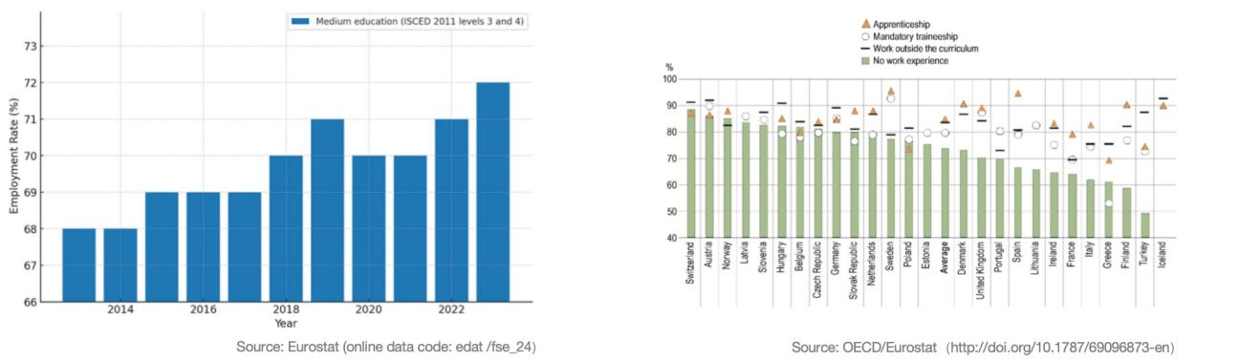

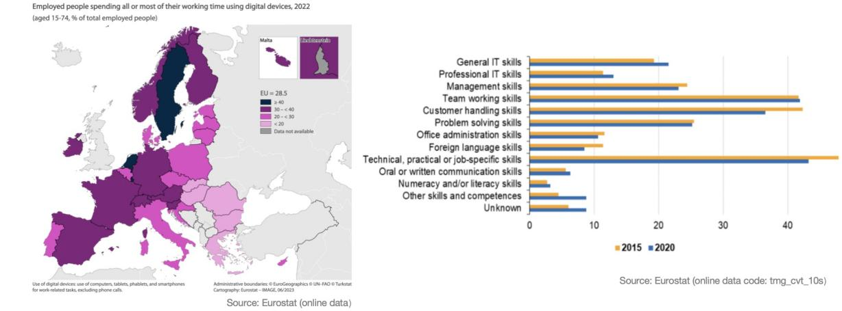

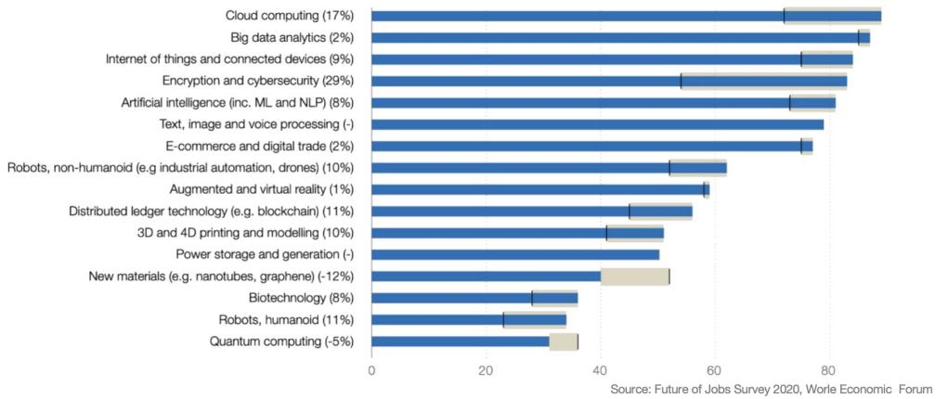

Figure 5. Technologies Likely to Be Adopted by 2025 (by Share of Companies Surveyed)

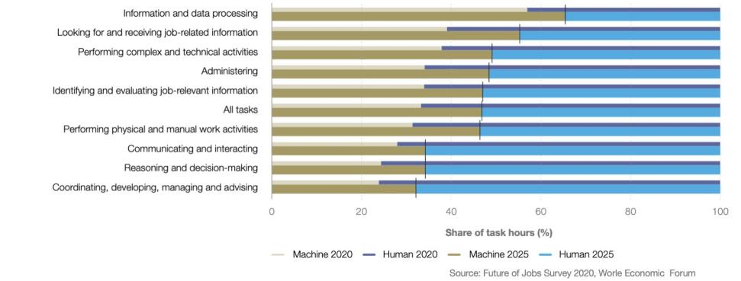

Figure 6. Share of Tasks Performed by Humans vs Machines, 2020 and 2025 (Expected), by Share of Companies Surveyed

Figure 7 Educational Reform Model in Industry-Academia Colleges

Key Aspects of Teaching Reform:

* *Development of Specialized Clusters:* Establish specialized groups based on market demands and corporate requirements, ensuring that students’ academic learning is closely aligned with their future career paths.
* *Optimization of the Curriculum System:* Ensure that the curriculum content is closely aligned with industry needs, fostering high-quality talent with practical skills and an innovative mindset.
* *Practical Teaching:* Strengthen students’ practical skills and work competencies through cognitive practice, comprehensive training, and vocational skills training.
* *Innovation and Entrepreneurship Education:* Enhance students’ innovation capabilities and entrepreneurial awareness through creative development, innovative design, and entrepreneurial incubation (Zhang, 2024; Leong 2023). Establish incubation platforms to help students turn ideas into products, providing business and management training to encourage entrepreneurship.
* *Development of Dual-Qualified Teaching Staff:* Implement a “dual-teacher” training model where industry experts and school teachers jointly participate in teaching, encouraging teachers to obtain both industry and educational certifications to enhance their comprehensive teaching abilities.
* *On-the-Job Training:* Provide technical, operational, and managerial training to ensure students acquire practical skills and industry-recognized certifications, thereby increasing their employability.
* *Employment System:* Deepen collaboration with enterprises to offer targeted employment opportunities, helping students transition directly into the workforce upon graduation.
* *Quality Assurance System:* Establish and improve the quality assurance system for talent cultivation, with a focus on enhancing the quality of education to ensure that what students learn aligns with market demands, thereby boosting their employability.

**Results and Recommendation**

Through the implementation of education reforms in industry colleges, significant progress has been made across multiple dimensions, particularly in enhancing students’ innovation and entrepreneurship capabilities, strengthening interdisciplinary knowledge, cultivating multi-skilled talent, optimizing curriculum quality, and improving students’ employability. These achievements indicate that the teaching reform model of industry colleges has not only effectively promoted the comprehensive development of students but has also successfully aligned with societal needs.

Figure 8 Effectiveness of Educational Reforms in Industry Colleges

Building on the notable success of the industry college teaching reforms, the next steps should focus on further consolidating and expanding these achievements. To this end, systematic measures are needed to ensure the long-term development of students, while continuously innovating teaching methods using cutting-edge technologies to meet the evolving demands of society and industry. The following are two key directions for improvement:

* Tracking Student Career Development: Establish a system to continuously monitor and evaluate students’ career development over the long term.
* Innovation in Technology and Teaching Methods: Explore the use of innovative teaching methods such as Virtual Reality (VR), Augmented Reality (AR), Artificial Intelligence (AI), and Digital Twins to enhance the student learning experience.

**Conclusion**

Vocational colleges lead important changes in education by creating professional groups, changing the curriculum, and improving teaching methods.

The measures aim to improve graduates' ability to find jobs and compete effectively by increasing awareness of innovation, supporting faculty development, promoting lifelong learning, and strengthening employment systems and quality control.

The demand for interdisciplinary skills is increasingly vital as students transition from vocational training to the workforce. Students equipped with a blend of technical knowledge, digital literacy, and soft skills such as creativity and emotional intelligence are more likely to thrive in this rapidly evolving job market. Industry 5.0 places a significant emphasis on human-machine collaboration, which shifts the skill requirements of various sectors. Vocational colleges need to prioritize training in advanced technologies like robotics, AI, and the Internet of Things (IoT), while also fostering critical thinking and problem-solving skills that enhance students’ employability. This approach meets industry demands and contributes to industrial development and regional economic growth. The employment status of vocational college students under Industry 5.0 depends on the responsiveness of educational institutions to new technological trends and the evolving demands of the workforce. By integrating Industry 5.0 principles into vocational education, institutions can enhance student employability and ensure a future-ready workforce that is adaptive, resilient, and skilled in both human and technological domains.

**References**

Antón, J. I., Klenert, D., Fernández-Macías, E., Urzì Brancati, M. C., & Alaveras, G. (2022). The labour market impact of robotisation in Europe. European Journal of Industrial Relations, 28(3), 317-339. <https://doi.org/10.1177/09596801211070801>

Bhaskar, P., Tiwari, C. K., & Joshi, A. (2021). Blockchain in education management: present and future applications. Interactive Technology and Smart Education, 18(1), 1-17. <https://doi.org/10.1108/ITSE-07-2020-0102>

Ghosh, L., & Ravichandran, R. (2024). Emerging Technologies in Vocational Education and Training. Journal of Digital Learning and Education, 4(1), 41-49. <https://doi.org/10.52562/jdle.v4i1.975>

Gamberini, L., & Pluchino, P. (2024). Industry 5.0: A comprehensive insight into the future of work, social sustainability, sustainable development, and career. Australian Journal of Career Development, 33(1), 5-14. <https://doi.org/10.1177/10384162241231118>

Kühn, S. (2020). 1 Global employment and social trends. World Employment and Social Outlook, 2020(1), 15-38. <https://doi.org/10.1002/wow3.158>

Kumar, R., Kapil, A. K., Athavale, V., Yie, L. W., & Touzene, A. (2023). The catalyst for clean and green energy using blockchain technology. In Modeling for Sustainable Development: A Multidisciplinary Approach (pp. 23-39). Nova Science Publishers, Inc. <https://squ.elsevierpure.com/en/publications/the-catalyst-for-clean-and-green-energy-using-blockchain-technolo>

Leong, W. Y., Chuah, J. H., & Tuan, T. B. (Eds.). (2020). The Nine Pillars of Technologies for Industry 4.0. Institution of Engineering and Technology. <https://doi.org/10.1049/PBTE088E>

Leong, W. Y., Leong, Y. Z., & San Leong, W. (2024, April). Human-Machine Interaction in the Electric Vehicle Battery Industry. In 2024 10th International Conference on Applied System Innovation (ICASI) (pp. 69-71). IEEE. <https://doi.org/10.1109/ICASI60819.2024.10547945>

Leong, W.Y., Leong, Y.Z., and Leong, W.S. (2023). Virtual reality in education: case studies and applications,  IET International Conference on Engineering Technologies and Applications (ICETA 2023), pp. 186 – 187. <https://doi.org/10.1049/icp.2023.3332>

Leong, W. Y., & Zhang, J. B. (2023). Engineer 5G to Transform Healthcare Industry. ASM Science Journal, 18, 2023. <https://doi.org/10.32802/asmscj.2023.1339>

López Peláez, A., Erro-Garcés, A., & Gómez-Ciriano, E. J. (2020). Young people, social workers and social work education: The role of digital skills. Social Work Education, 39(6), 825-842. <http://dx.doi.org/10.1080/02615479.2020.1795110>

Marinič, P., & Pecina, P. (2023). Industry 5.0 in vocational education. In INTED2023 Proceedings (pp. 3805-3811). IATED. <http://dx.doi.org/10.21125/inted.2023.1018>

Meng, W., & Sumettikoon, P. (2022). The use of artificial intelligence to enhance teaching effectiveness in vocational education. Eurasian Journal of Educational Research, 98(98), 266-283. <https://ejer.com.tr/manuscript/index.php/journal/article/view/743>

Nuraeni, Y., & Suwadji, Y. T. (2020, March). Strategy for enhancing quality of labor through technical vocational education & training faces industry 4.0 challenges. In International Conference On Elementary Education (Vol. 2, No. 1, pp. 1255-1272). <https://www.academia.edu/63999294/Strategy_for_Enhancing_Quality_of_Labor_through_Technical_Vocational_Education_and_Training_Faces_Industry_4_0_Challenges>

Özdemir, V., & Hekim, N. (2018). Birth of Industry 5.0: Making sense of big data with artificial intelligence, the internet of things and next-generation technology policy. Omics: A Journal of Integrative Biology, 22(1), 65-76. <https://doi.org/10.1089/omi.2017.0194>

Passalacqua, M., Cabour, G., Pellerin, R., Léger, P. M., & Doyon-Poulin, P. (2024). Human-centered AI for industry 5.0 (HUMAI5. 0): Design framework and case studies. In Human-centered AI (pp. 260-274). Chapman and Hall/CRC. <https://doi.org/10.1201/9781003320791-27>

Rial-Gonzalez, P., Sarceda-Gorgoso, M. C., & Queiruga, O. S. (2024). Lifelong learning as a response to the challenges of Industry 5.0 within the context of Horizon 2030. R EDUCAR, 60(2), 305-319. <https://doi.org/10.5565/REV/EDUCAR.2054>

Weiland, S., Hickmann, T., Lederer, M., Marquardt, J., & Schwindenhammer, S. (2021). The 2030 agenda for sustainable development: transformative change through the sustainable development goals?. Politics and Governance, 9(1), 90-95. <https://www.cogitatiopress.com/politicsandgovernance/article/view/4191>

Xuan, T. R., & Ness, S. (2023). Integration of Blockchain and AI: exploring application in the digital business. Journal of Engineering Research and Reports, 25(8), 20-39. <https://doi.org/10.9734/jerr/2023/v25i8955>

Zhang, H. (2020). The integration of IoT in vocational education: A case study. Technology and Education Journal, 22(1), 67-80.

Zhang, H.L., Leong, W.Y.(2024). AI Solutions for Accessible Education in Underserved Communities." Journal of Innovation and Technology 2024. <https://doi.org/10.61453/joit.v2024no11>